1. Bubble Sort

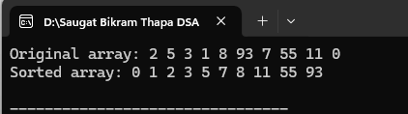

1. Selection Sort

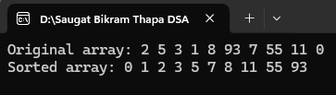

1. Heap Sort

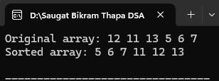

1. QuickSort

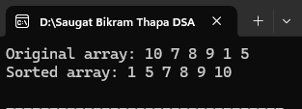

1. Insertion Sort

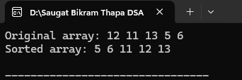

1. Merge Sort

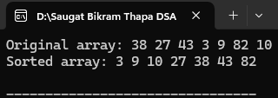

1. Shell Sort

